Quadratic Roots

#include <math.h>

#include <stdio.h>

int main()

{ float a, b, c, dis, r1, r2, realPart, imagPart;

printf("Enter coefficients a, b and c: ");

scanf("%f %f %f", &a, &b, &c);

dis = (b\*b)- (4\*a\*c);

if (dis > 0)

{ r1 = (-b + sqrt(dis)) / (2 \* a);

r2 = (-b - sqrt(dis)) / (2 \* a);

printf("Roots are distinct - root1 = %0.2f and root2 = %0.2f", r1, r2);

}

else if (dis == 0)

{ r1 = r2 = -b / (2 \* a);

printf("Roots are equal - root1 = root2 = %0.2f;", r1);

}

else

{ realPart = -b / (2 \* a);

imagPart = sqrt(- dis) / (2 \* a);

printf("Roots are complex - root1 = %0.2f+ i %0.2f and root2 = %0.2f- i %0.2f", realPart, imagPart, realPart, imagPart);

}

return 0;

}

Distinct roots 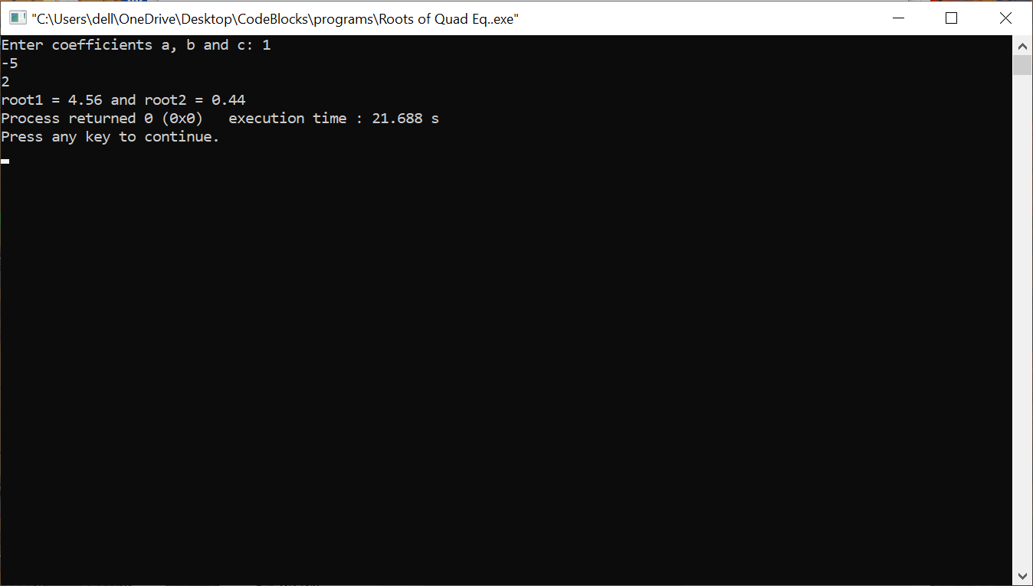

Same roots 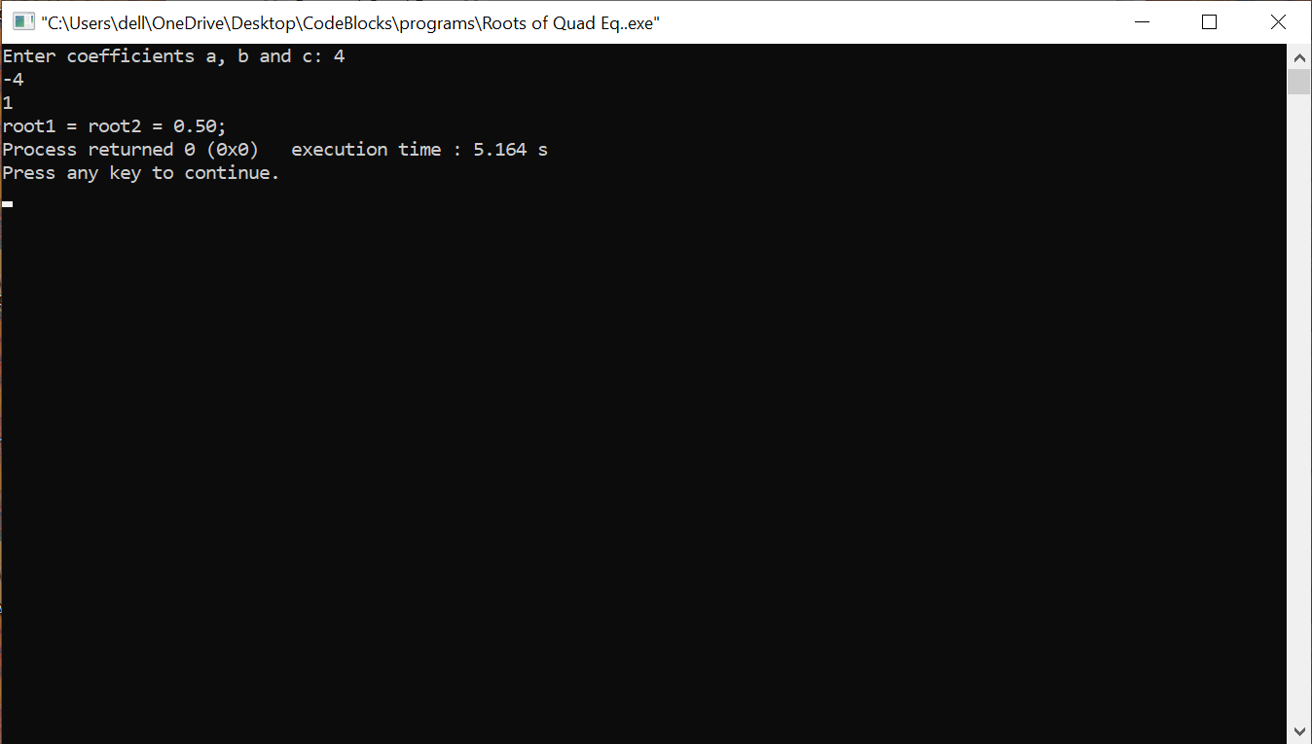

Complex roots 